Product Requirements Document

SVH hall effect speed sensor

Issued by | Role/Department | Date
Chiara Facchini | Electronics Division Leader | 24/10/2025

TABLE OF CONTENTS
GENERAL PRODUCT DESCRIPTION 3
DESIGN 3
INTERFACE 3
ELECTRICAL HARDWARE AND SENSORS 3
TEST DA FARE 3
BOM 3
REPORT 3

GENERAL PRODUCT DESCRIPTION

Product Description
Key Features/ Functionality | Hall-effect speed sensor, ideal for  measuring the speed of bolts and tone wheels
Working conditions | Content in the phonic wheel  Operating temperature: -30°C ÷ +110°C  Degree of Protection: IP67  CNC-machined anodized aluminum body for  excellent mechanical resistance to impacts.
Rules | No
Dimensions and Tolerances | Cfr. Rendering section
Weight | ≈ 26 g
Produzione | Aviorace SRL

REGULATORY
Regulatory Requirements
Safety
Structural
Electrical

DESIGN
Renderings | 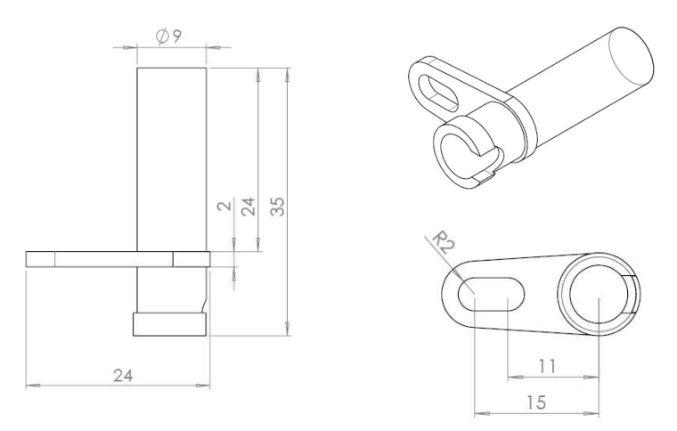

ENVIRONMENT
Operating Environment
Where in the car | Front structure
Temperature Range | -30°C ÷ +110°C

ELECTRICAL HARDWARE AND SENSORS

Supply Voltage | 5 ÷ 18 Vdc
Supply Current | Maximum output current: 25 mA  Current consumption at 12 VDC: < 20 mA
Input/Sensor Requirements | https://aviorace.com/wp-content/uploads/2021/01/SVH-rev6.pdf

BOM

Bill of material
BOM
Financials
BOM Cost

